**South Plains College**

**Department of Kinesiology**

**KINE 1336**

**Sport Management (Online) Fall 2024**

**Instructor**: Ryan Heth **Office Phone**: 806.716.2234

**Office**: Kinesiology Building #107

**Office Hours**:  Posted below and on blackboard **Email**: [rheth@southplainscollege.edu](mailto:rheth@southplainscollege.edu)

Text Book: ***Contemporary Sport Management 07th edition Pedersen and Thibault***

**Course Description**

This course provides an overview of the sports industry and introduces basic administration, marketing, and management principles.

**Student Learning Outcomes:**

1. Identify basic principles that encompass the field of sport management within the vast arena of the sports industry.
2. Develop a professional perspective, exhibit a professional attitude, and develop professional skills.
3. Understand the historical development of sports as a pastime to sports as a career and business.
4. Identify numerous careers and professional organizations related to sports management and the path to those careers.
5. Critically think about and evaluate the major challenges in the field of sport management.
6. Develop verbal and written communication skills to write and present in a professional and scholarly manner.
7. Explain sport's sociological aspects and effects in your community, region, state, and country.
8. Recognize the vast array of responsibilities in sports management that include budgeting, marketing, staffing, and fundraising components from both the private and public sectors.

**Student Expectations**

To acquire knowledge and build skills, students are expected to:

• Read and become familiar with the course syllabus and expectations.

• Keep up with assignments and readings.

• Ask for clarifications about material or course expectations.

• Analyze assigned readings and offer thoughtful interpretations.

• Be respectful of diverse perspectives and refrain from making inappropriate comments on discussion boards and personal interactions in class.

**Blackboard** is the computer software used to deliver quizzes and other class information. You must have reliable access to the Internet, Microsoft Word, PowerPoint, Excel, Adobe, etc. If you do not have a computer at home, you can access this information in a computer lab on the SPC Levelland campus and the SPC Lubbock Downtown campus. You will have deadlines set for you throughout the semester. If you wait until a few hours before assignments are due and have technical difficulties, they may not be corrected in time to get credit for the assignment. Have a backup plan in place should you encounter computer problems. Open computer labs are available to all enrolled SPC students on all campuses.

**\**

**Course Evaluation:**

1. There will be **three exams,** each worth 70 points (210 points total:42% of your overall grade.) Each exam will consist of 50-100 questions (multiple-choice, essay, fill-in-the-blank, matching, etc.).
2. **Quizzes** There will be a total of 15 quizzes in this course. Each quiz is worth 10 points (150 points total; 30% of your overall grade) and will be posted on blackboard. Each quiz will consist of multiple-choice, true-false, or essay-type questions. You can only take each quiz once, and you must finish the quiz once you begin. You will not be able to leave the quiz and return to it later. *Once you enter the quiz, you must finish!* Please use your notes and textbook to complete the quizzes. These quizzes will help prepare you for the exams.
3. **Two Homework Assignments** will be completed over the semester. Each homework will be worth 40 points (80 points total; 16% of your overall grade).
4. **Online Discussion Topics/ Attendance** will be completed in class and turned in, each worth up to 5-10 points (60 points total; 12% of your overall grade). The primary goal of the course's discussion portion assignments is to think critically about what you are learning. These will also be used to keep up with attendance.

If you accumulate six absences, you will be dropped from the course. There are no makeups allowed for this portion of your grade. Absences will be recorded in your journal to keep up with throughout the semester.

* I expect you to read the chapters assigned. This exposes you to the material and makes it easier for you to understand the PowerPoint slides and take good notes.

**Final grades** will be determined as follow:

* 3 examinations @ 70 points each: 210 points
* 15 quizzes @ 10 points each 150 points
* 2 homework assignments @ 40 points each 80 points
* Classroom discussion/ Journal/ Attendance 60 points

**Total: 500**

**Final Grade Point Percentage Point Total**

A 90-100% 448-500

B 80-89% 398-447

C 70-79% 348-397

D 60-69% 298-347

F Below 60% Below 298

**TexBook Syllabus Statement**

This course is part of your TexBook program, which means you don’t need to purchase a textbook or access code for this course. TexBook is the required content (either an eBook or online Courseware) for your course, and is provided for you via the Bibliu platform from Day 1 of class.

* Cost of TexBook: this required content is provided as part of a Program called ‘Inclusive Access’, which means that content is provided for you at the lowest price available from the publisher. The cost for this is included in your tuition.
* How to access your digital content via Bibliu: you can access your material via the Bibliu link inside your Blackboard Course, or directly via the Bibliu app. If you have issues with this, please contact your professor, the Bookstore Manager or Bibliu Support (see below).
* The Bibliu platform: you can use the Bibliu platform to enhance your learning experience, with features including: highlighting, notes and reading text aloud. For more details and support on how to use Bibliu, please visit the [BibliU support pages](https://support.bibliu.com/hc/en-us), or contact Bibliu support via the email: [support@bibliu.com](mailto:support@bibliu.com)
* Opting out: you can Opt-Out of the TexBook Program, up until the Opt-Out deadline, via the banner displayed when you open the Bibliu platform. Remember that Opt-Out deadlines vary by term, and if you choose to Opt-Out you will lose access to this low price option, and will need to purchase the content through a different method. If you opt-Out, the fee will be refunded to your account.

Useful contacts:

1. Bookstore Manager: Christian Bruno - [christian.bruno@bibliu.com](mailto:christian.bruno@bibliu.com)
2. Bookstore Text Coordinator: Trish Wells - [patricia.wells@bibliu.com](mailto:patricia.wells@bibliu.com)
3. Bibliu Support: email [support@bibliu.com](mailto:support@bibliu.com)

# Academic Information

A student who stops attending AND stops completing assignments must take the responsibility of contacting the Registrar's Office to drop the class.

***I do not drop students for non-attendance.  You are responsible for initiating the drop process if you decide not to complete the course.  Students who stop attending and do not complete the coursework will receive an F at the end of the semester.***

**Plagiarism and Cheating:**Students are expected to do their own work on all projects, quizzes, assignments, examinations, and papers. Failure to comply with this policy will result in an F for the assignment and can result in an F for the course if circumstances warrant.

Plagiarism violations include, but are not limited to, the following:

1. Turning in a paper that has been purchased, borrowed, or downloaded from another student, an online term paper site, or a mail order term paper mill;
2. Cutting and pasting together information from books, articles, other papers, or online sites without providing proper documentation;
3. Using direct quotations (three or more words) from a source without showing them to be direct quotations and citing them; or
4. Missing in-text citations.

Cheating violations include, but are not limited to, the following:

1. Obtaining an examination by stealing or collusion;
2. Discovering the content of an examination before it is given;
3. Using an unauthorized source of information (notes, textbook, text messaging, internet, apps) during an examination, quiz, or homework assignment;
4. Entering an office or building to obtain unfair advantage;
5. Taking an examination for another;
6. Altering grade records;
7. Copying another's work during an examination or on a homework assignment;
8. Rewriting another student's work in Peer Editing so that the writing is no longer the original student's;
9. Taking pictures of a test, test answers, or someone else's paper.

**Please see the following links for the South Plains College General Syllabus Statements and the Covid Policy.**

<https://www.southplainscollege.edu/syllabusstatements/>

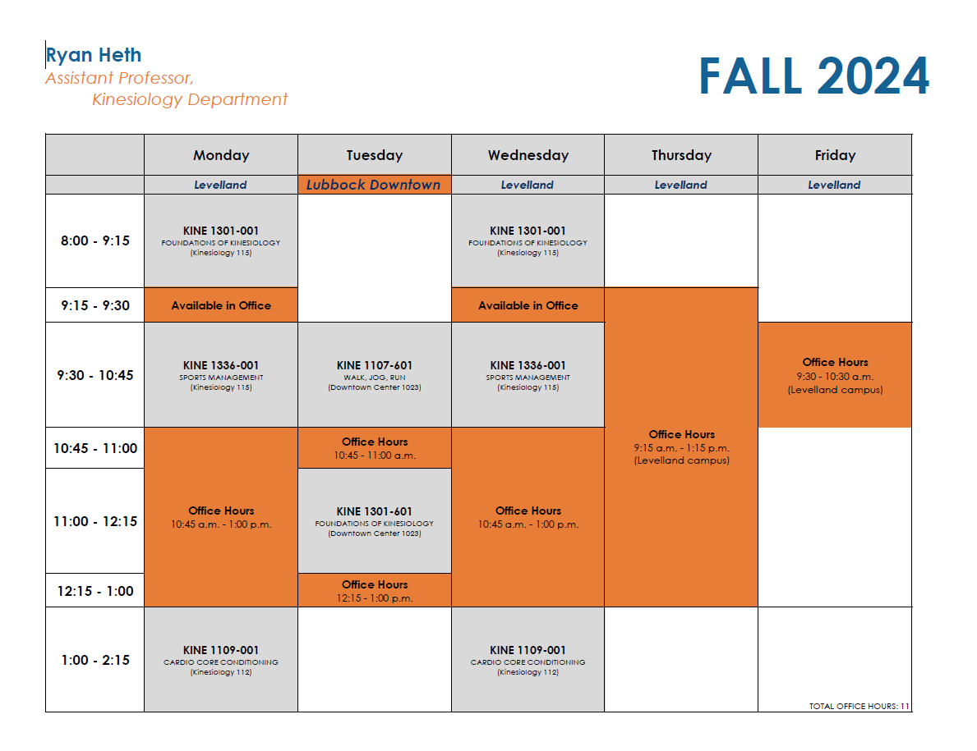 <https://www.southplainscollege.edu/emergency/covid19-faq.php>